Name: Nam Jun Lee

WSU ID: 011606459

Assignment: Assignment #3

Class number: 2021 Fall-MIS-325-ONLIN-2217-H72-01-10356-LEC

Date: November 5th , 2021

<https://cb-ot-devst06.ad.wsu.edu/MF13namjun.lee/Assignment3/Assignment3.aspx>

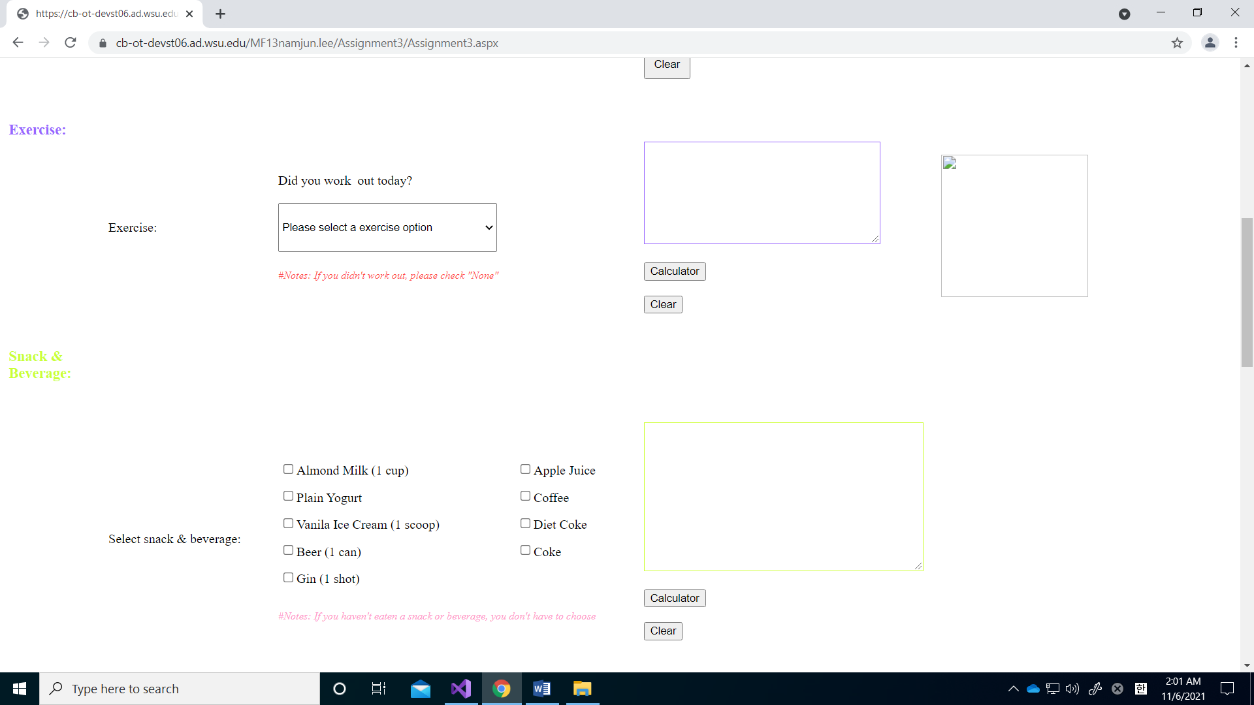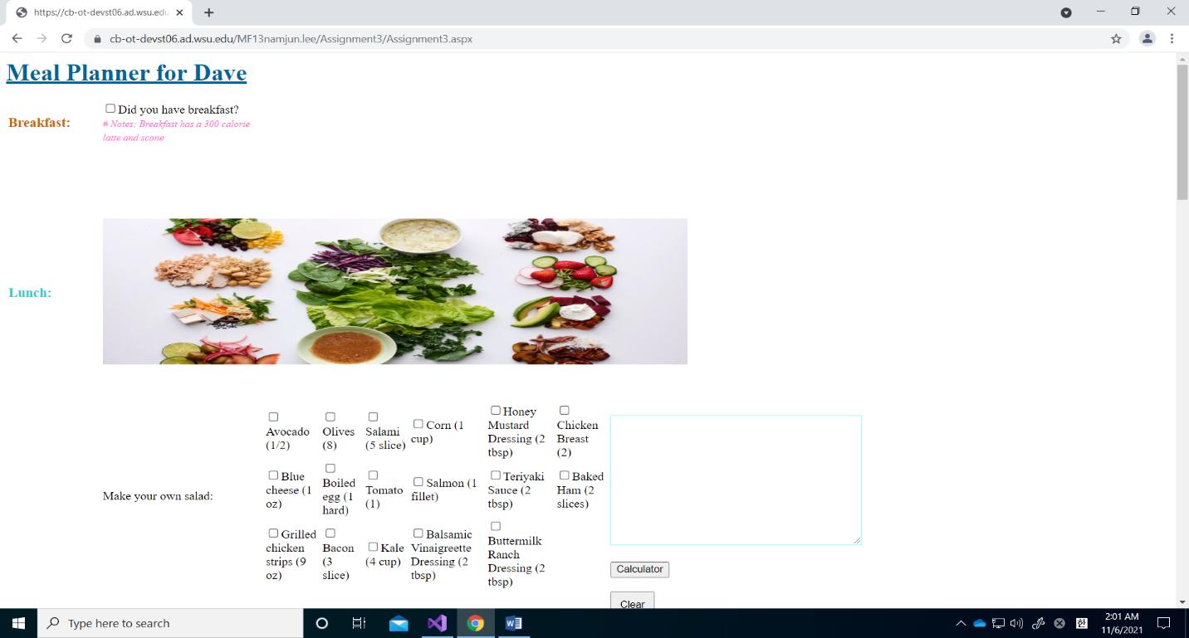

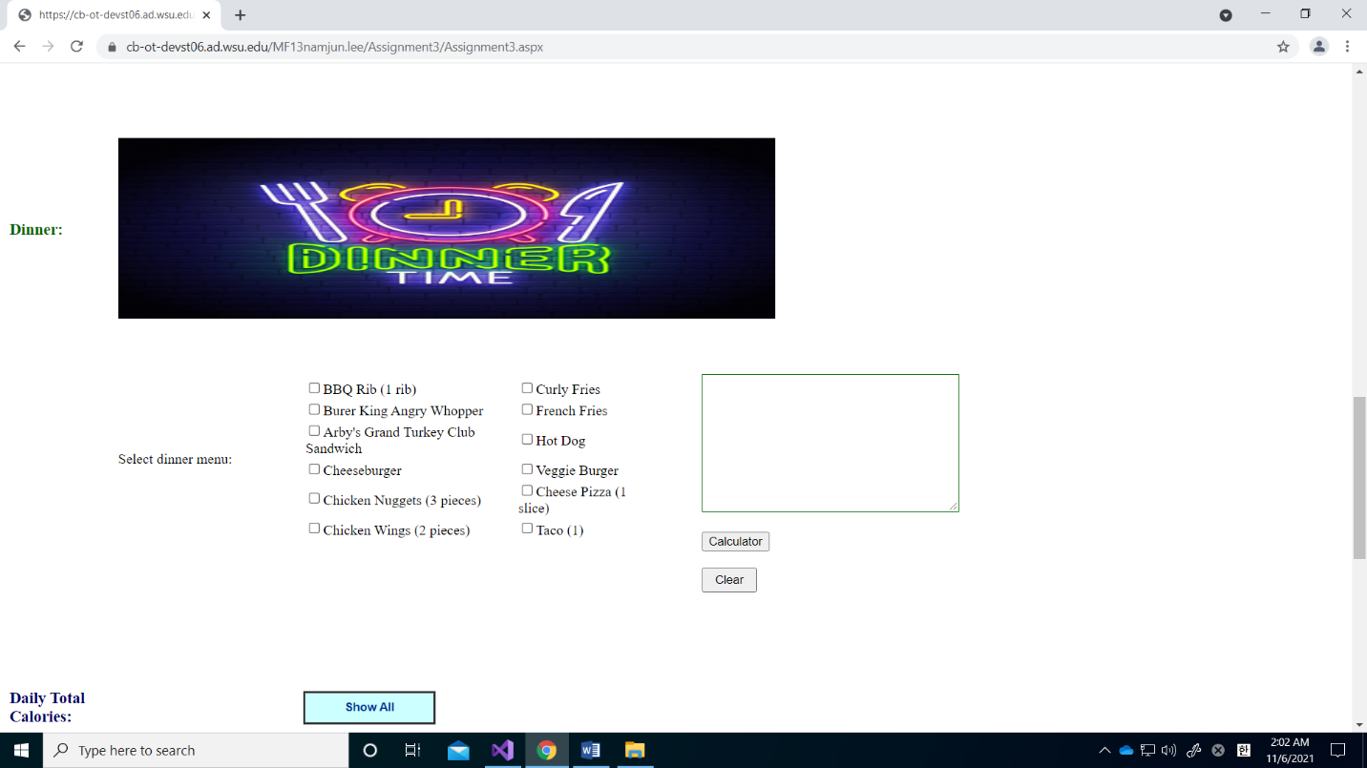

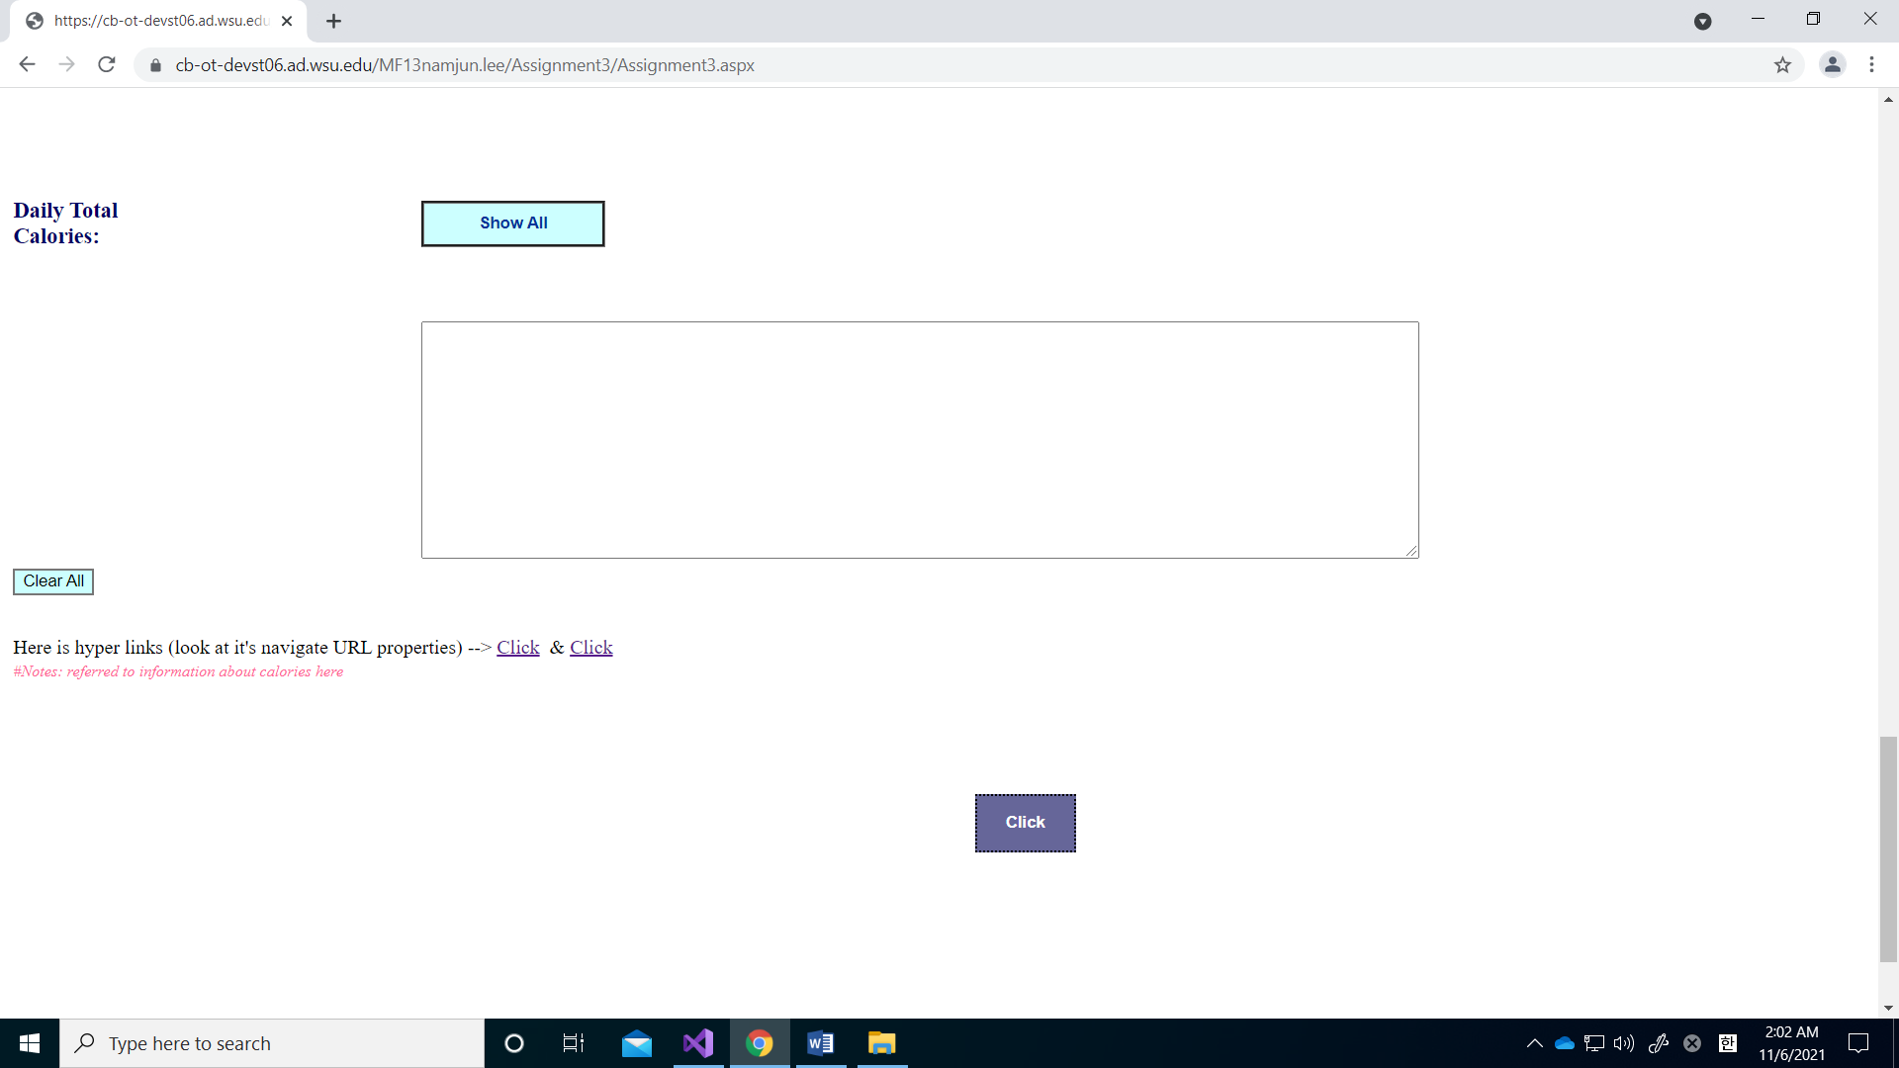

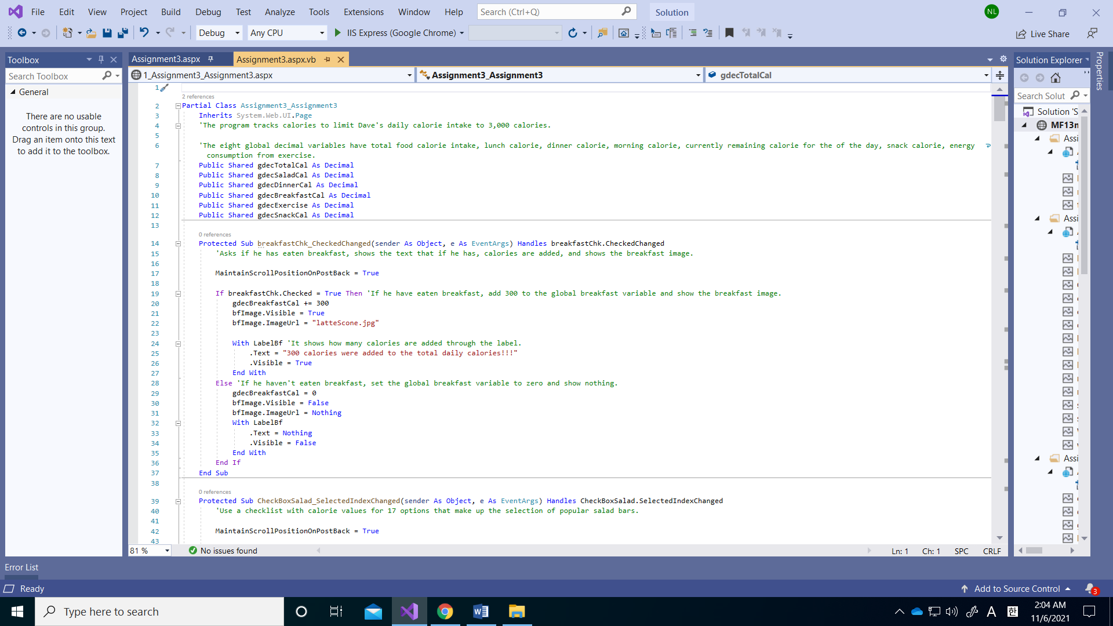

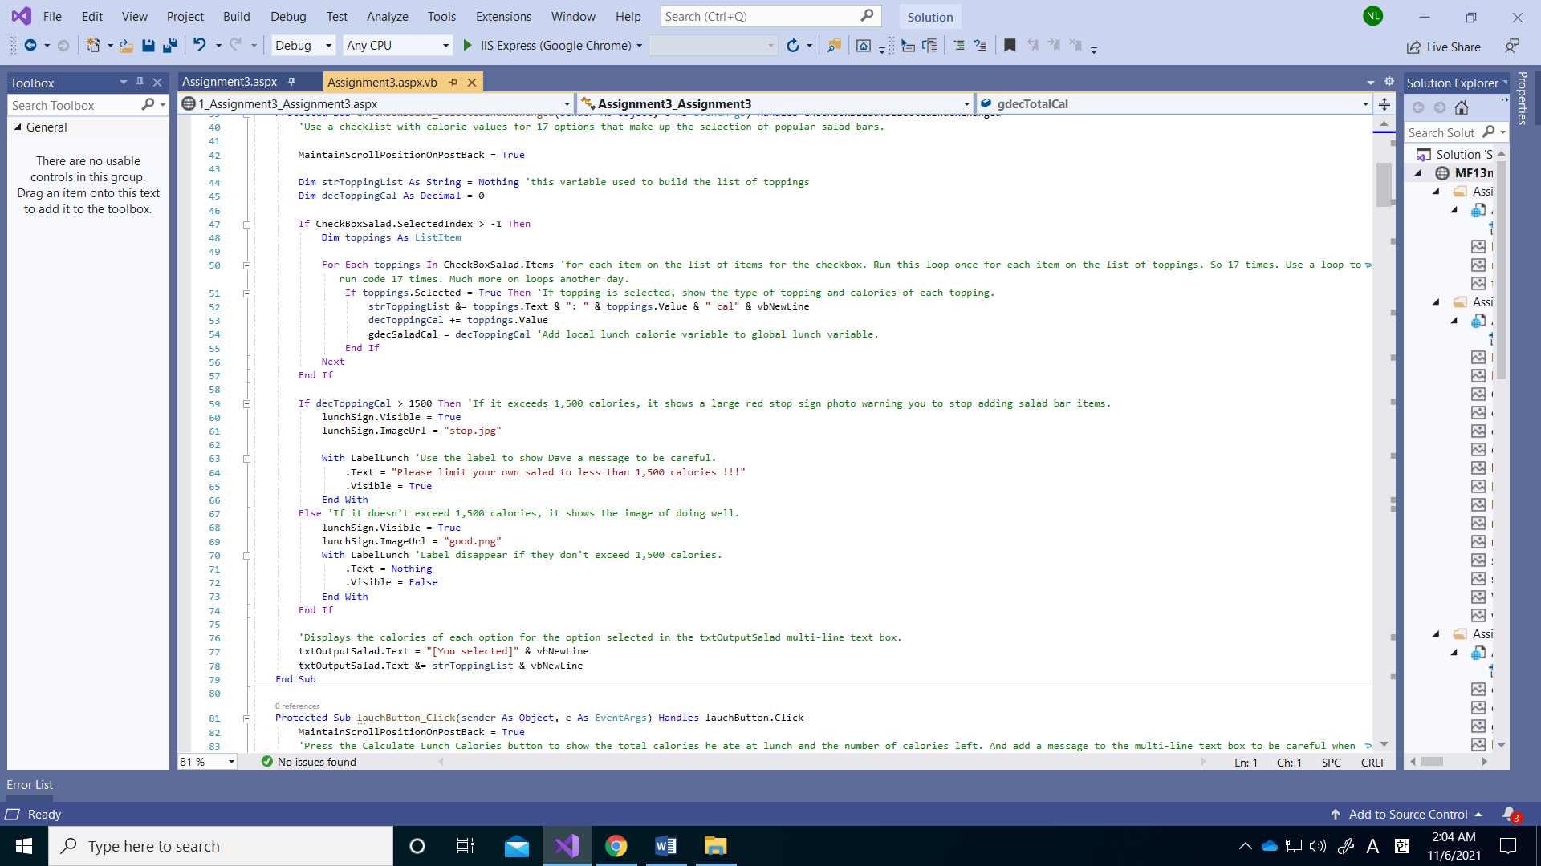

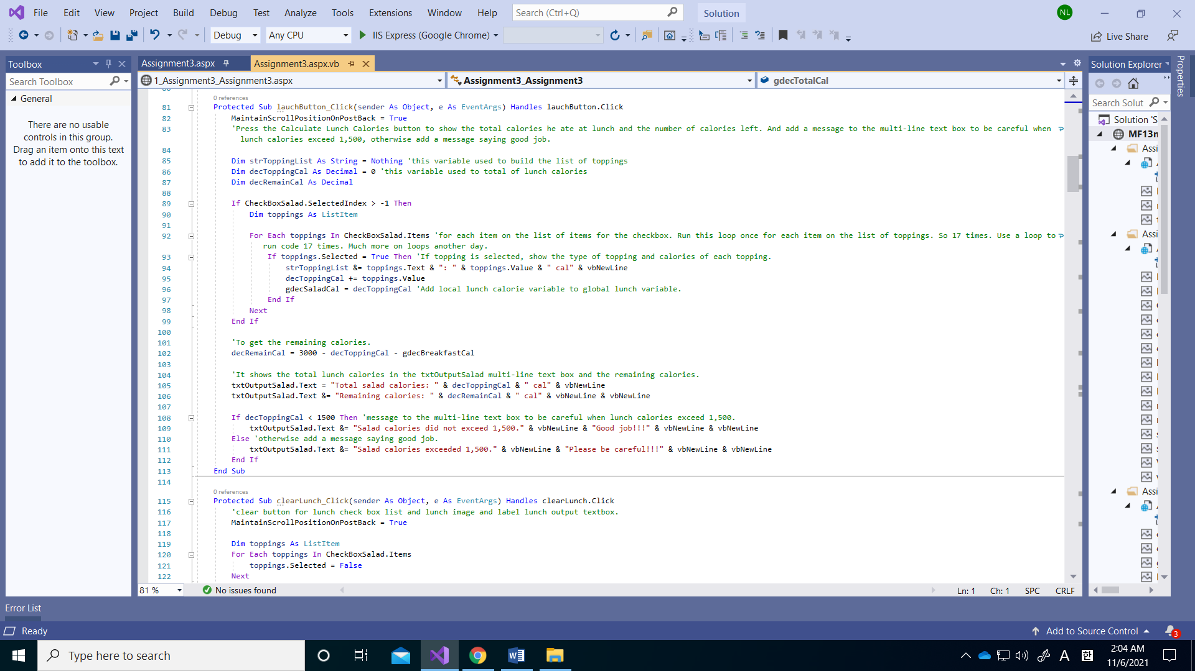

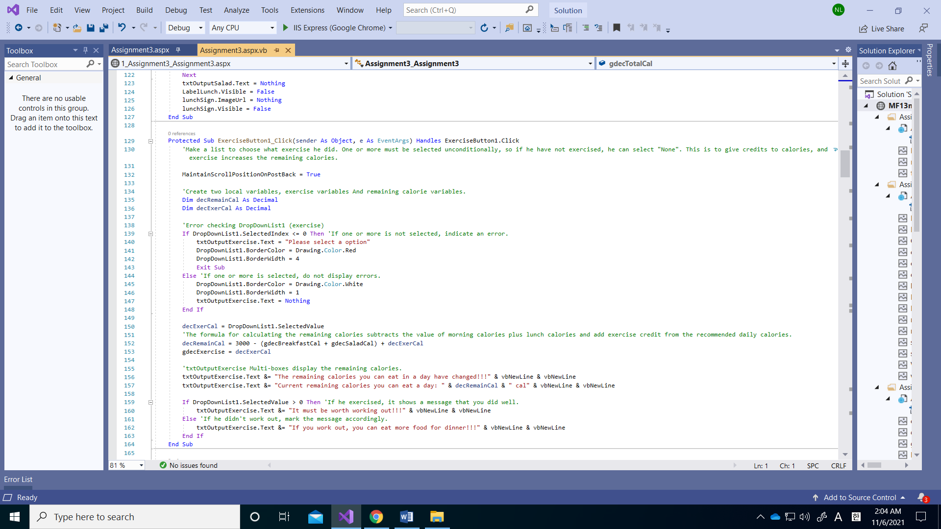

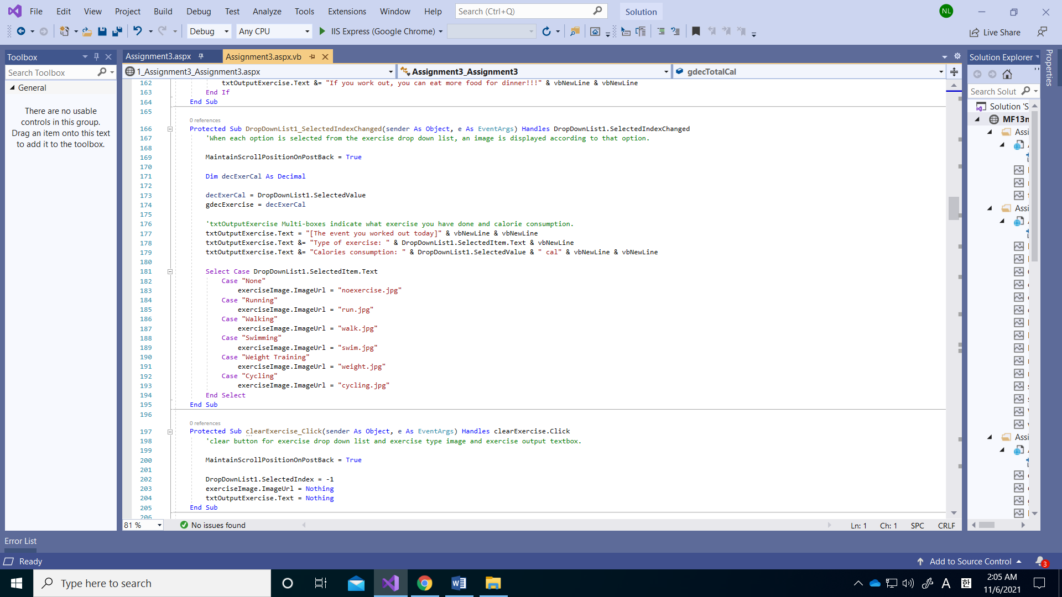

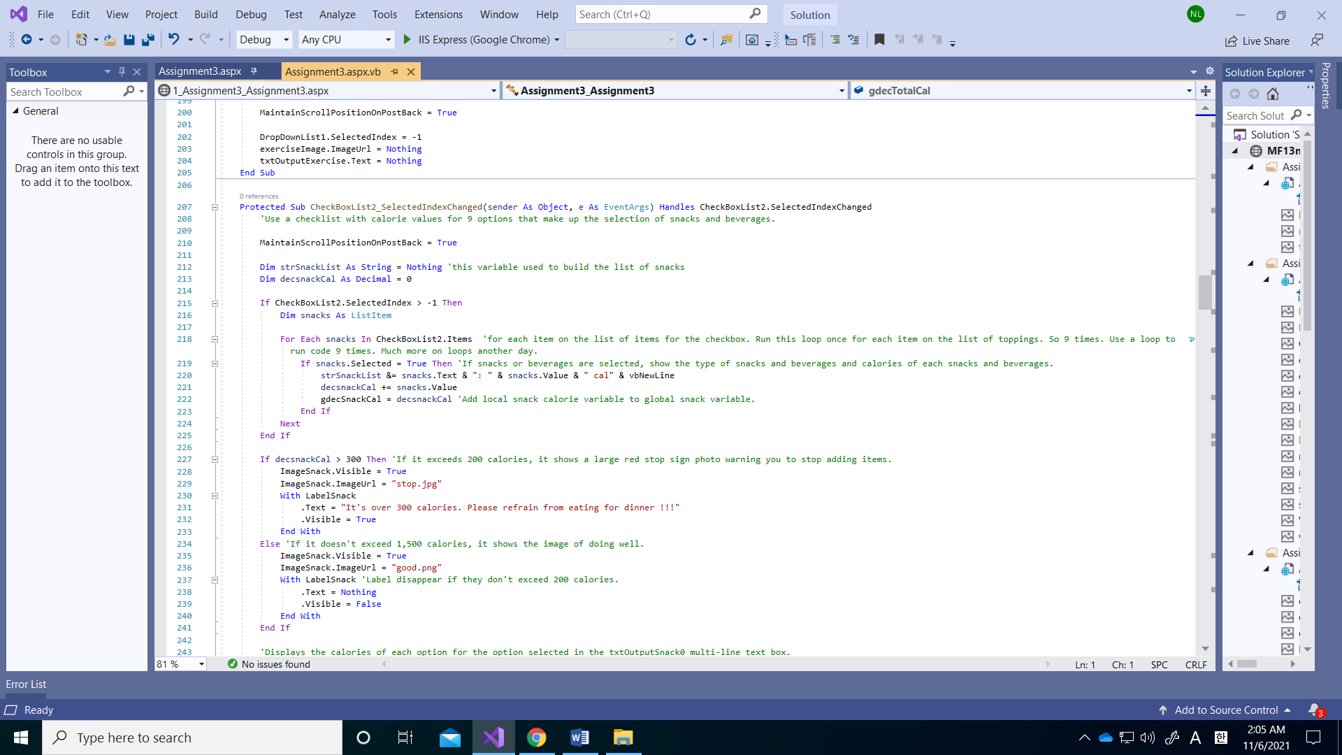

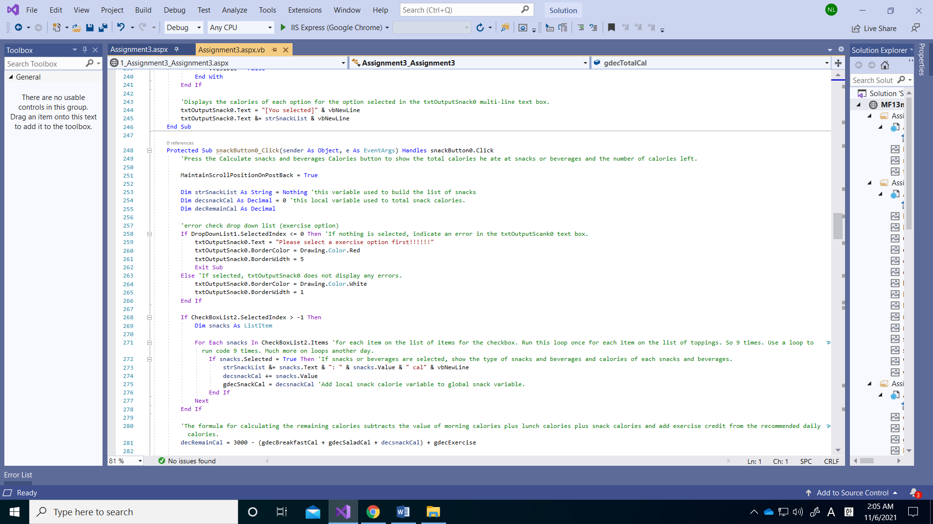

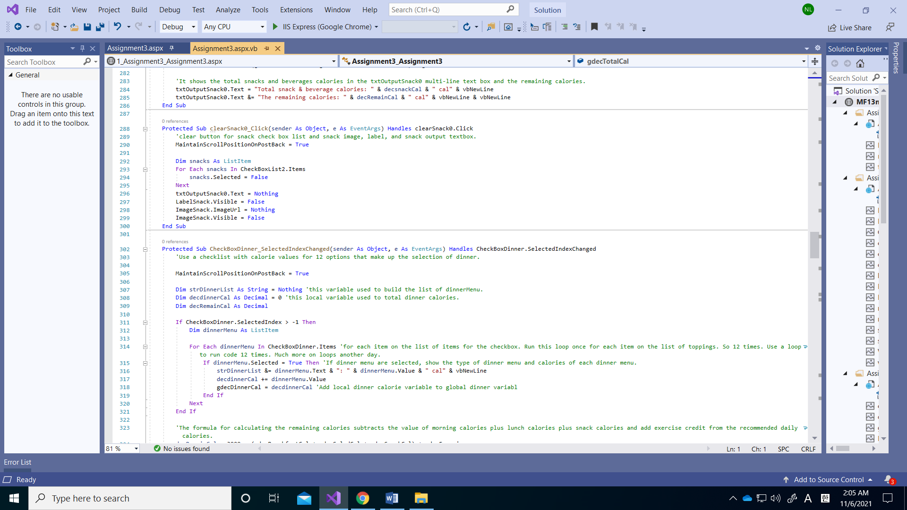

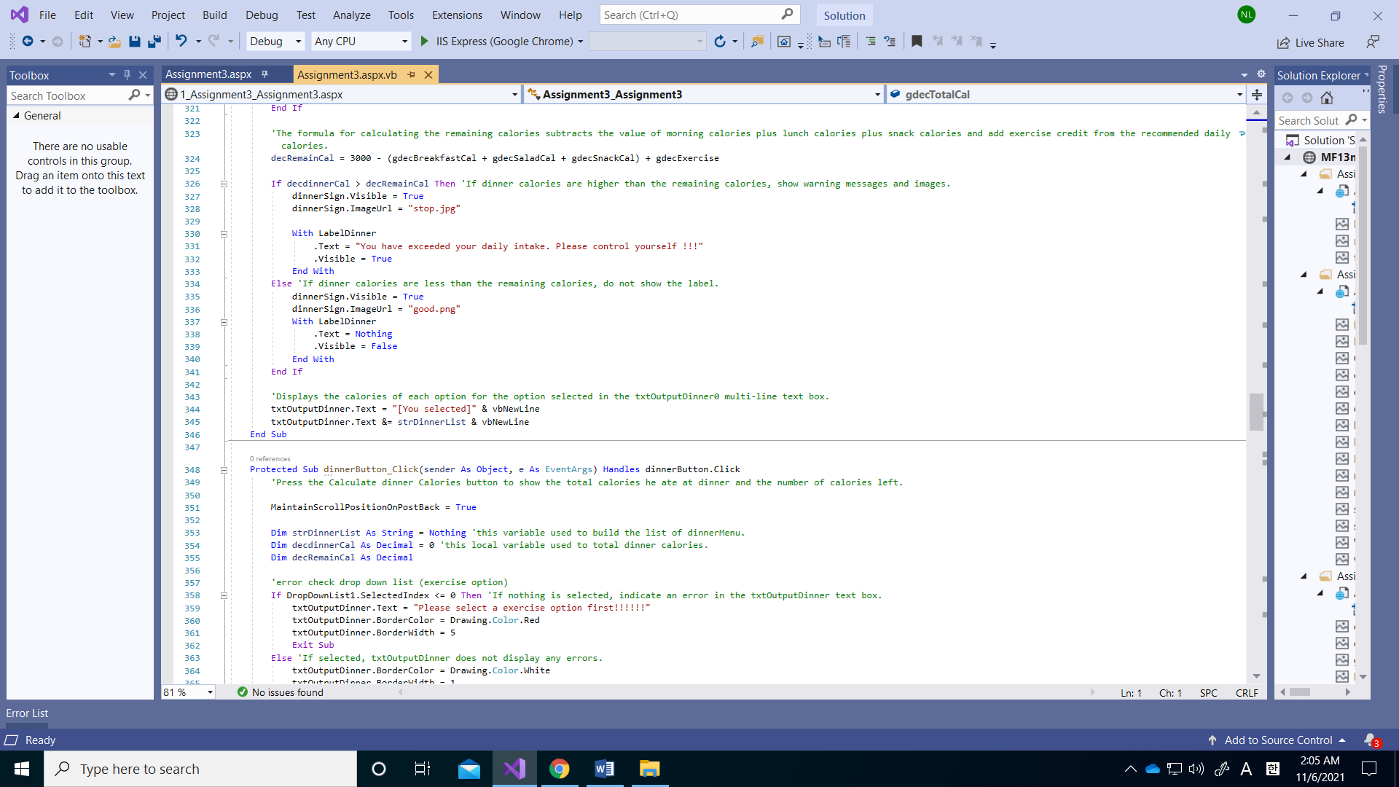

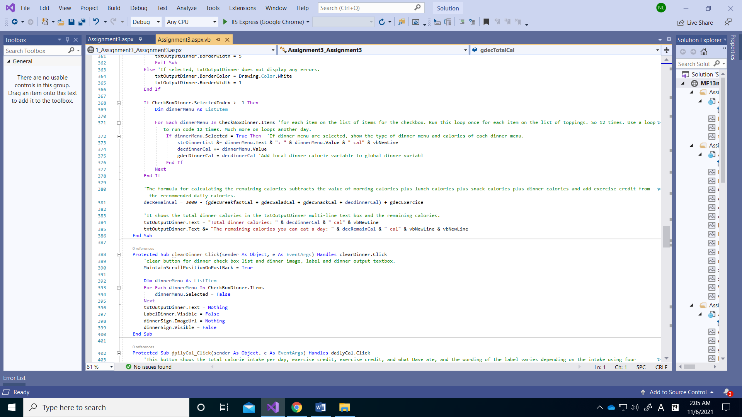

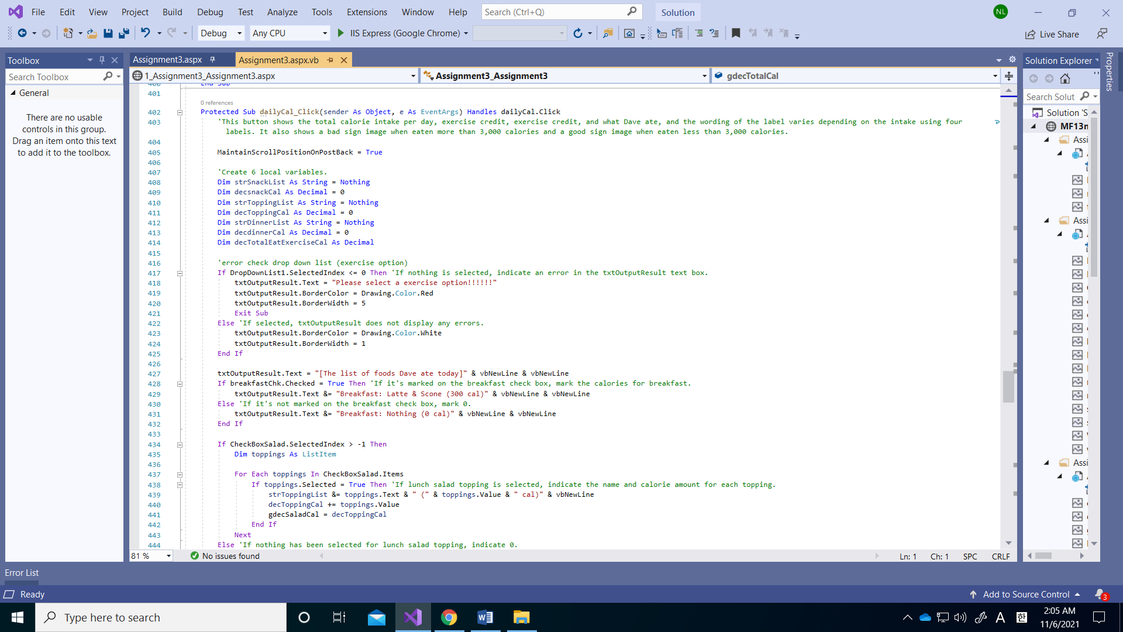

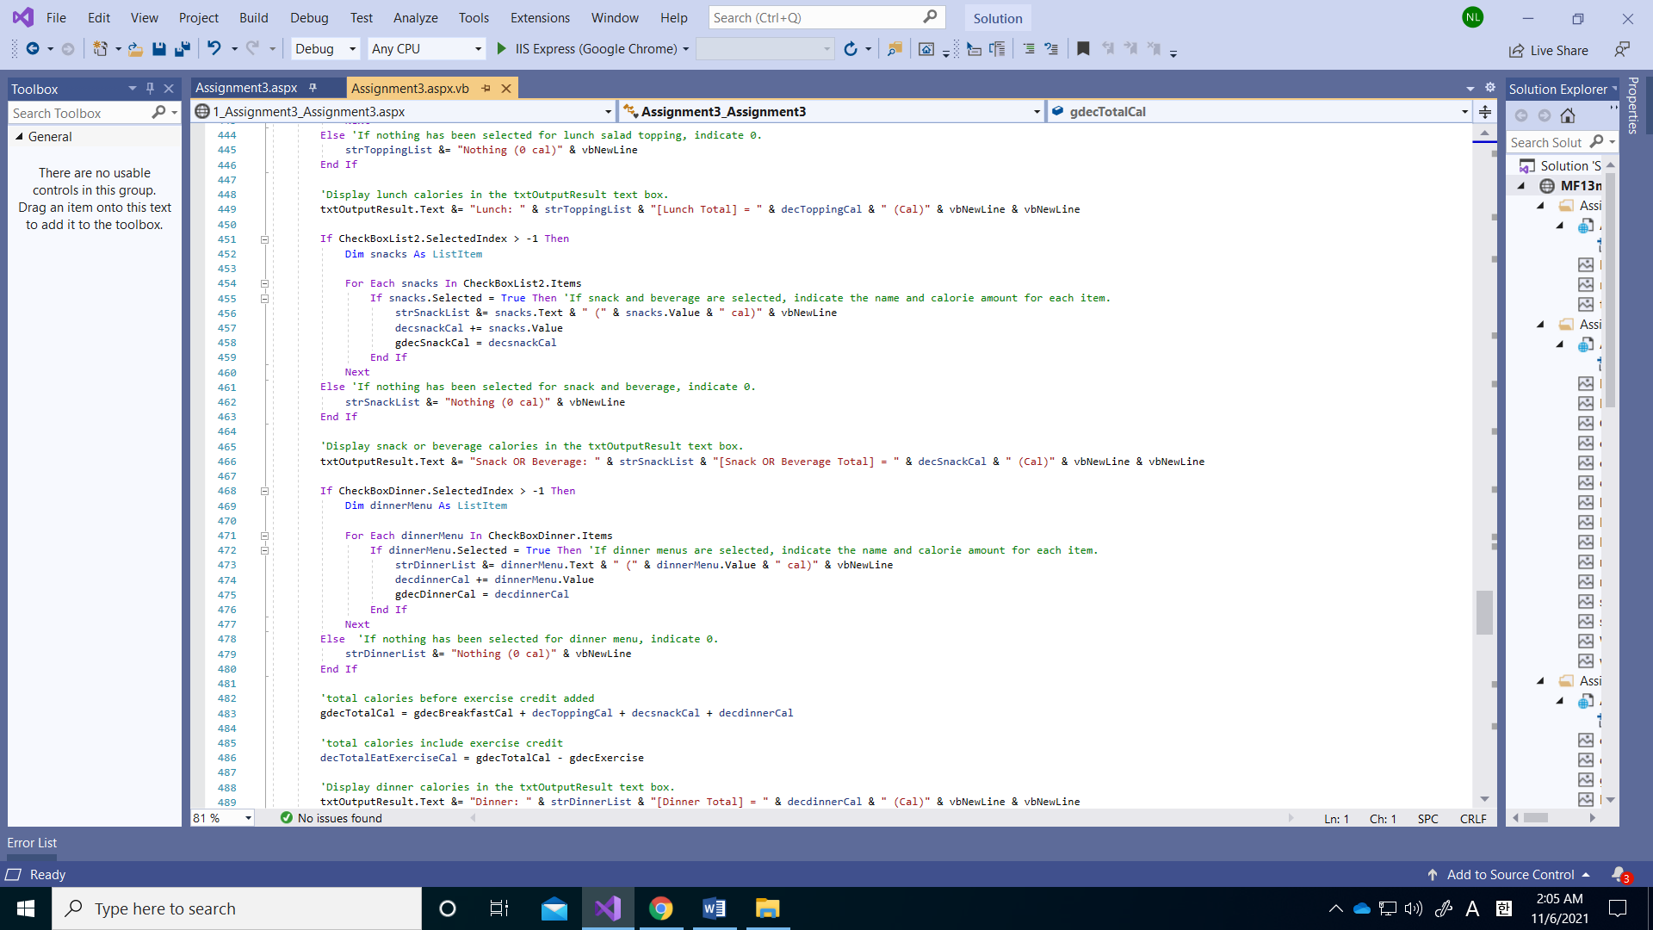

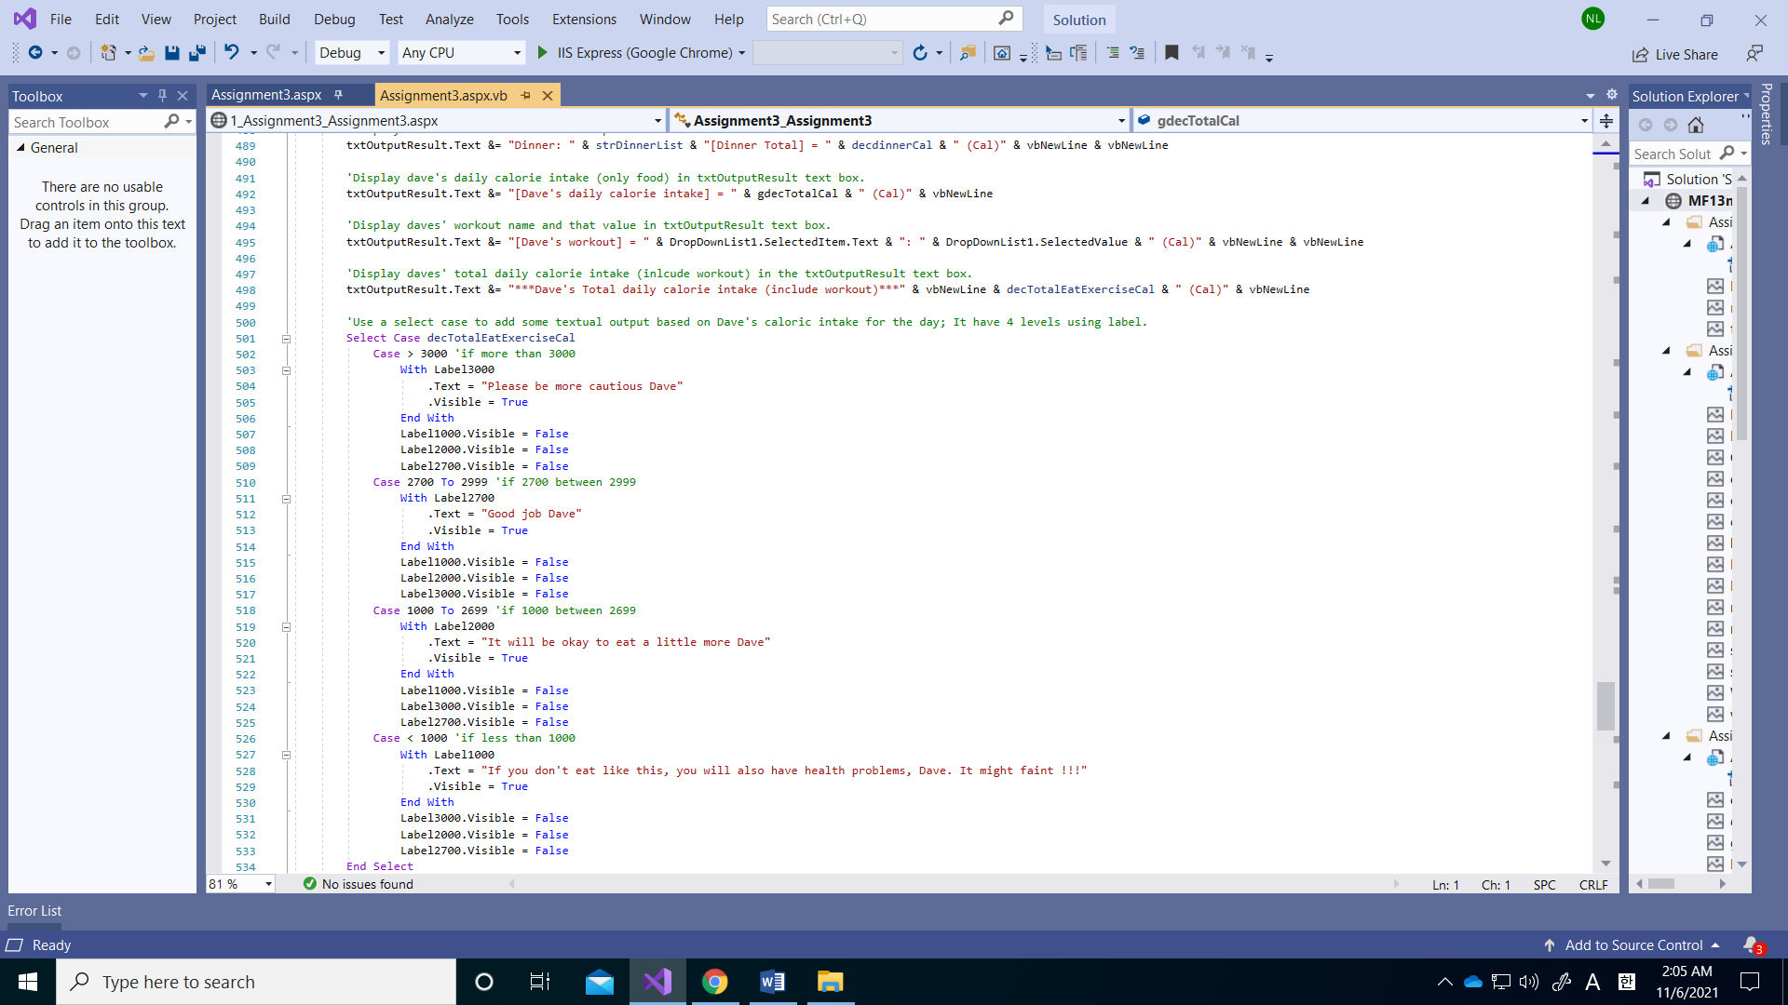

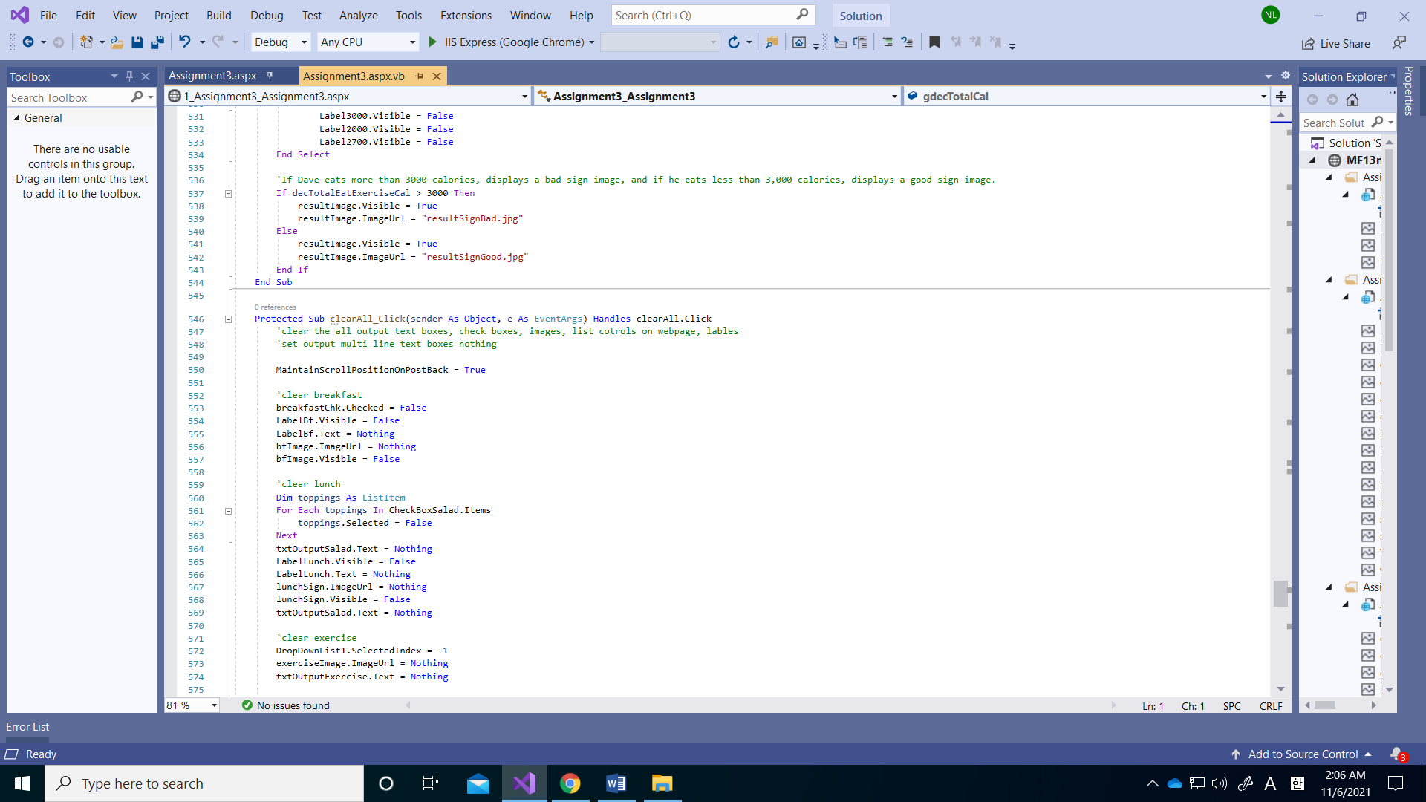

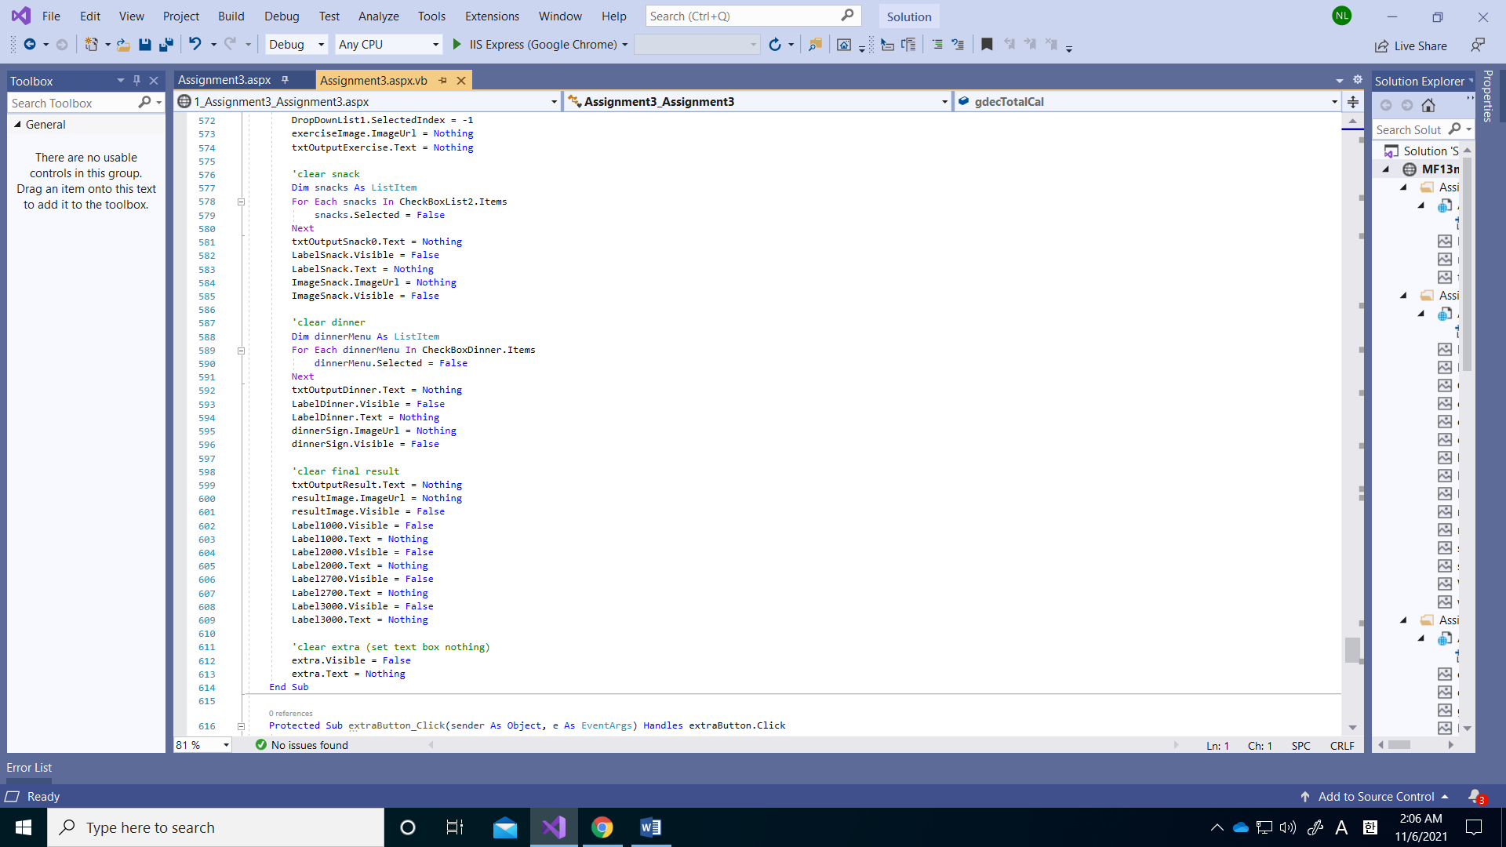

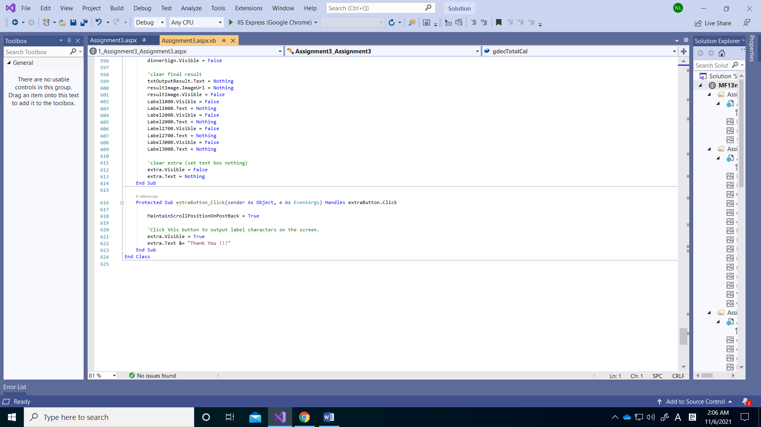

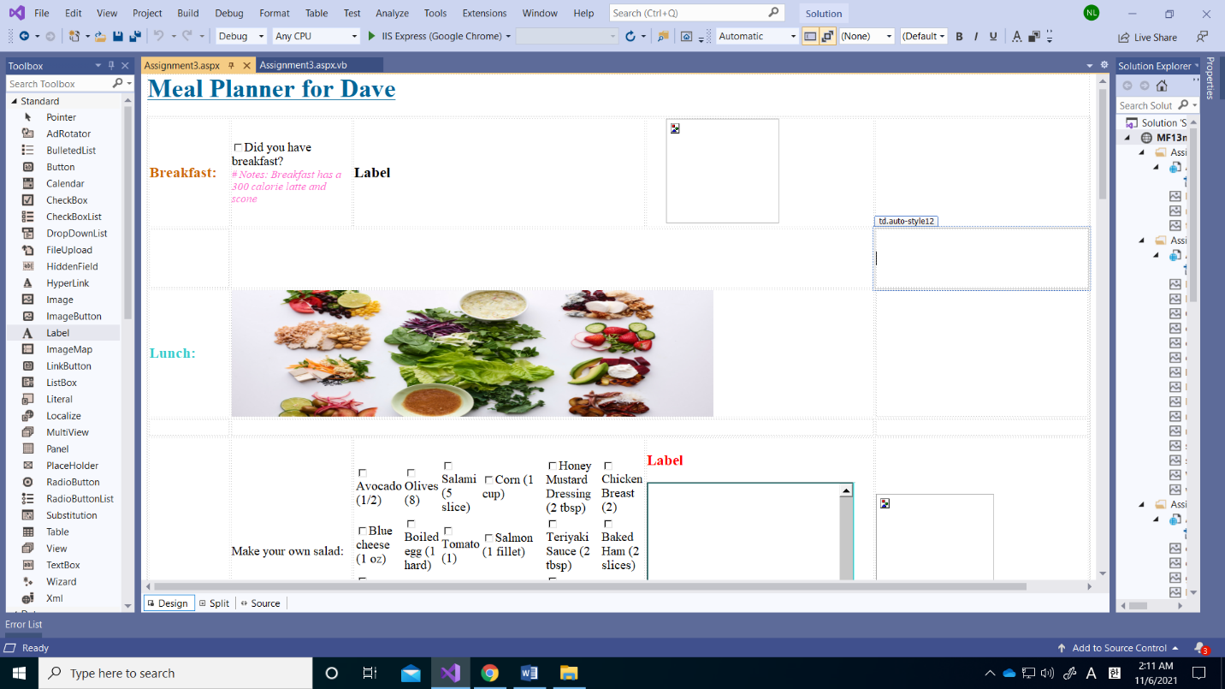

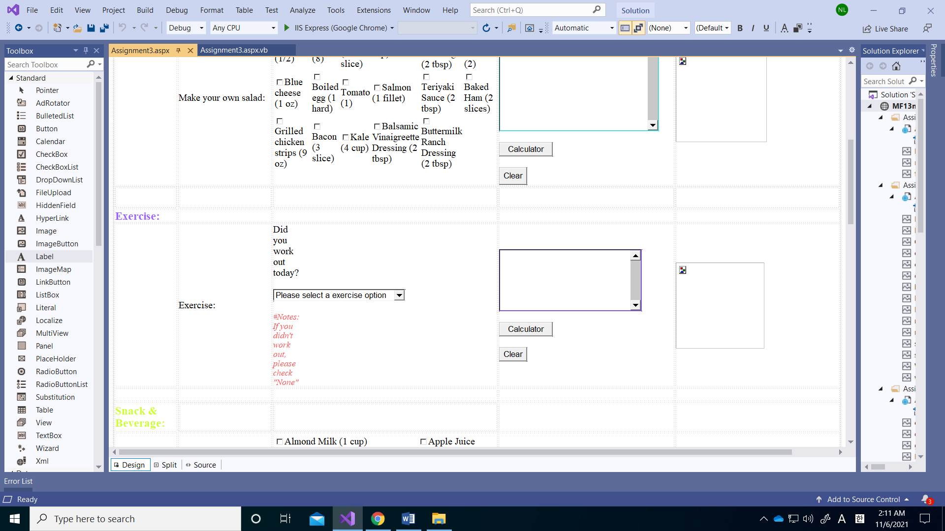

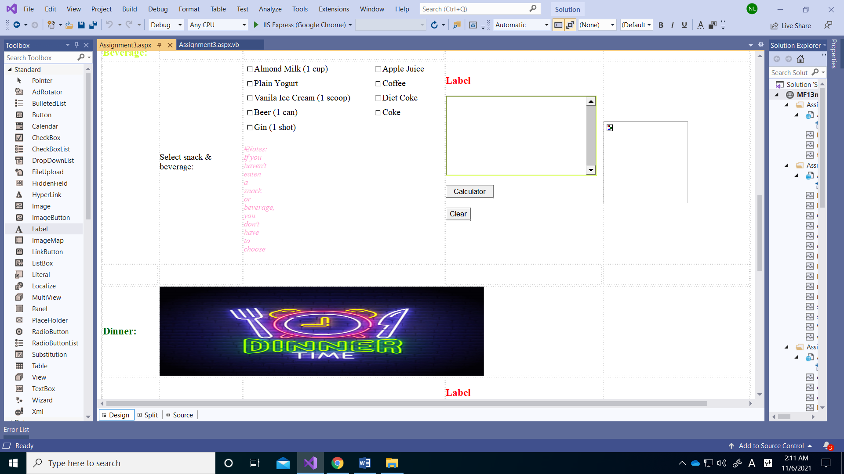

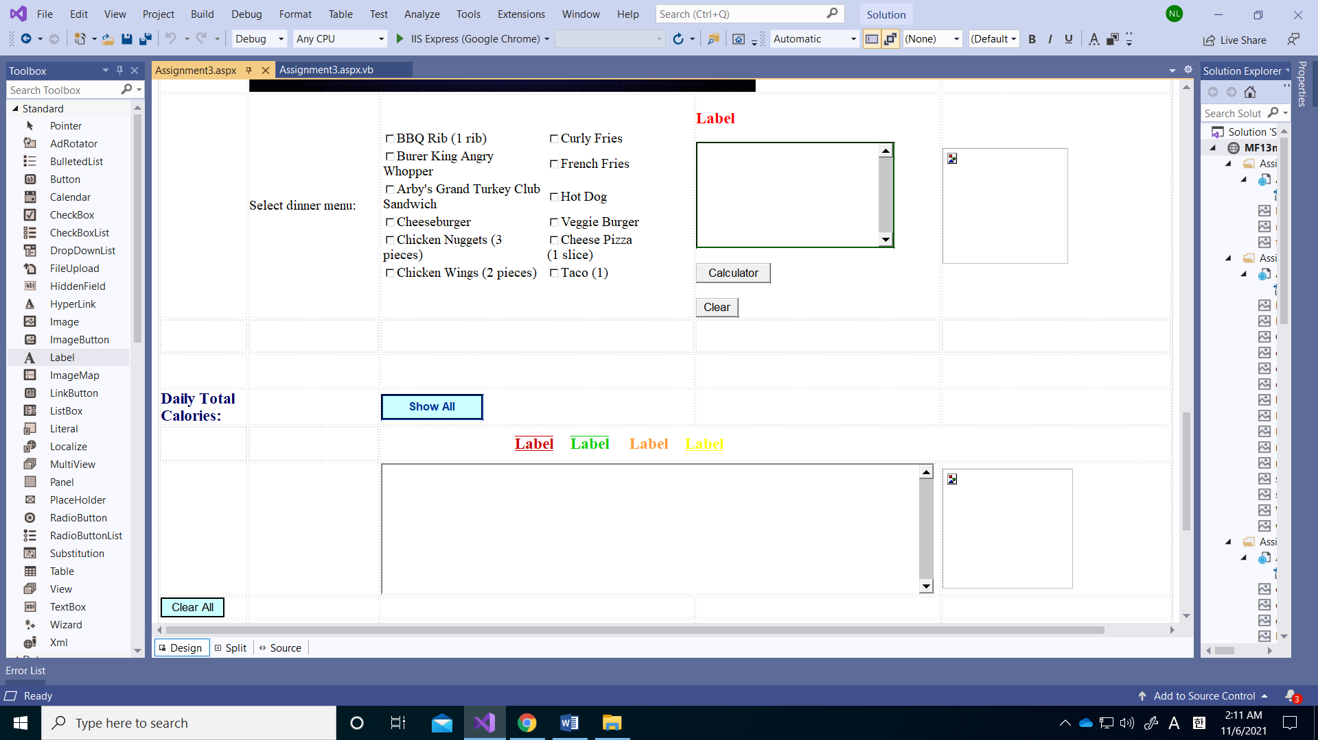

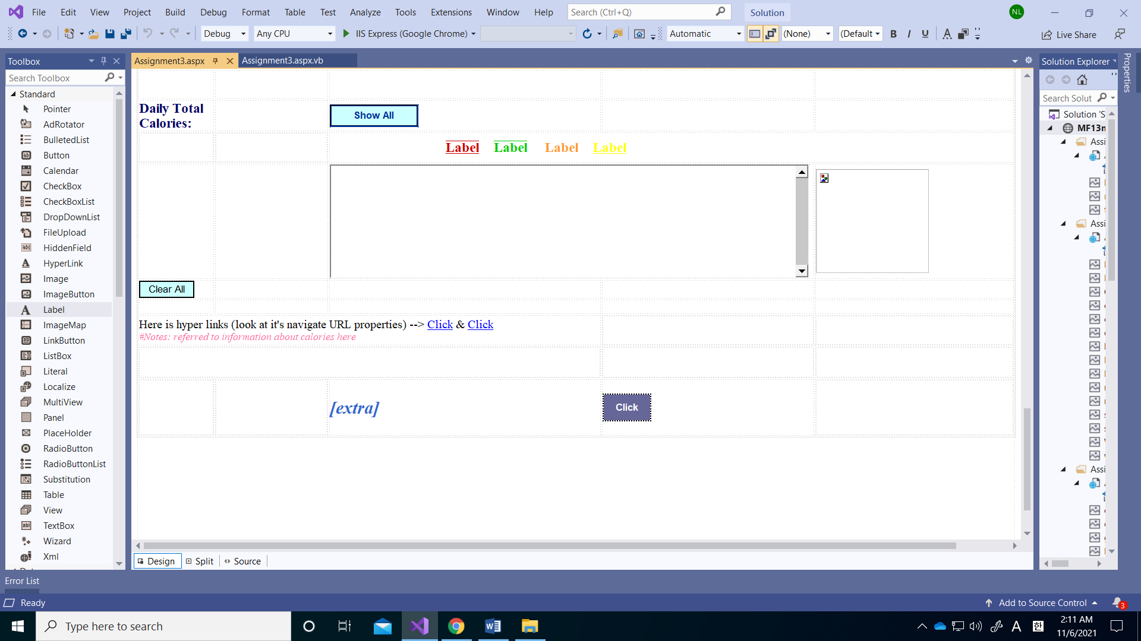

**Aspx.vb code:**

Partial Class Assignment3_Assignment3

Inherits System.Web.UI.Page

'The program tracks calories to limit Dave's daily calorie intake to 3,000 calories.

'The eight global decimal variables have total food calorie intake, lunch calorie, dinner calorie, morning calorie, currently remaining calorie for the of the day, snack calorie, energy consumption from exercise.

Public Shared gdecTotalCal As Decimal

Public Shared gdecSaladCal As Decimal

Public Shared gdecDinnerCal As Decimal

Public Shared gdecBreakfastCal As Decimal

Public Shared gdecExercise As Decimal

Public Shared gdecSnackCal As Decimal

Protected Sub breakfastChk_CheckedChanged(sender As Object, e As EventArgs) Handles breakfastChk.CheckedChanged

'Asks if he has eaten breakfast, shows the text that if he has, calories are added, and shows the breakfast image.

MaintainScrollPositionOnPostBack = True

If breakfastChk.Checked = True Then 'If he have eaten breakfast, add 300 to the global breakfast variable and show the breakfast image.

gdecBreakfastCal += 300

bfImage.Visible = True

bfImage.ImageUrl = "latteScone.jpg"

With LabelBf 'It shows how many calories are added through the label.

.Text = "300 calories were added to the total daily calories!!!"

.Visible = True

End With

Else 'If he haven't eaten breakfast, set the global breakfast variable to zero and show nothing.

gdecBreakfastCal = 0

bfImage.Visible = False

bfImage.ImageUrl = Nothing

With LabelBf

.Text = Nothing

.Visible = False

End With

End If

End Sub

Protected Sub CheckBoxSalad_SelectedIndexChanged(sender As Object, e As EventArgs) Handles CheckBoxSalad.SelectedIndexChanged

'Use a checklist with calorie values for 17 options that make up the selection of popular salad bars.

MaintainScrollPositionOnPostBack = True

Dim strToppingList As String = Nothing 'this variable used to build the list of toppings

Dim decToppingCal As Decimal = 0

If CheckBoxSalad.SelectedIndex > -1 Then

Dim toppings As ListItem

For Each toppings In CheckBoxSalad.Items 'for each item on the list of items for the checkbox. Run this loop once for each item on the list of toppings. So 17 times. Use a loop to run code 17 times. Much more on loops another day.

If toppings.Selected = True Then 'If topping is selected, show the type of topping and calories of each topping.

strToppingList &= toppings.Text & ": " & toppings.Value & " cal" & vbNewLine

decToppingCal += toppings.Value

gdecSaladCal = decToppingCal 'Add local lunch calorie variable to global lunch variable.

End If

Next

End If

If decToppingCal > 1500 Then 'If it exceeds 1,500 calories, it shows a large red stop sign photo warning you to stop adding salad bar items.

lunchSign.Visible = True

lunchSign.ImageUrl = "stop.jpg"

With LabelLunch 'Use the label to show Dave a message to be careful.

.Text = "Please limit your own salad to less than 1,500 calories !!!"

.Visible = True

End With

Else 'If it doesn't exceed 1,500 calories, it shows the image of doing well.

lunchSign.Visible = True

lunchSign.ImageUrl = "good.png"

With LabelLunch 'Label disappear if they don't exceed 1,500 calories.

.Text = Nothing

.Visible = False

End With

End If

'Displays the calories of each option for the option selected in the txtOutputSalad multi-line text box.

txtOutputSalad.Text = "[You selected]" & vbNewLine

txtOutputSalad.Text &= strToppingList & vbNewLine

End Sub

Protected Sub lauchButton_Click(sender As Object, e As EventArgs) Handles lauchButton.Click

MaintainScrollPositionOnPostBack = True

'Press the Calculate Lunch Calories button to show the total calories he ate at lunch and the number of calories left. And add a message to the multi-line text box to be careful when lunch calories exceed 1,500, otherwise add a message saying good job.

Dim strToppingList As String = Nothing 'this variable used to build the list of toppings

Dim decToppingCal As Decimal = 0 'this variable used to total of lunch calories

Dim decRemainCal As Decimal

If CheckBoxSalad.SelectedIndex > -1 Then

Dim toppings As ListItem

For Each toppings In CheckBoxSalad.Items 'for each item on the list of items for the checkbox. Run this loop once for each item on the list of toppings. So 17 times. Use a loop to run code 17 times. Much more on loops another day.

If toppings.Selected = True Then 'If topping is selected, show the type of topping and calories of each topping.

strToppingList &= toppings.Text & ": " & toppings.Value & " cal" & vbNewLine

decToppingCal += toppings.Value

gdecSaladCal = decToppingCal 'Add local lunch calorie variable to global lunch variable.

End If

Next

End If

'To get the remaining calories.

decRemainCal = 3000 - decToppingCal - gdecBreakfastCal

'It shows the total lunch calories in the txtOutputSalad multi-line text box and the remaining calories.

txtOutputSalad.Text = "Total salad calories: " & decToppingCal & " cal" & vbNewLine

txtOutputSalad.Text &= "Remaining calories: " & decRemainCal & " cal" & vbNewLine & vbNewLine

If decToppingCal < 1500 Then 'message to the multi-line text box to be careful when lunch calories exceed 1,500.

txtOutputSalad.Text &= "Salad calories did not exceed 1,500." & vbNewLine & "Good job!!!" & vbNewLine & vbNewLine

Else 'otherwise add a message saying good job.

txtOutputSalad.Text &= "Salad calories exceeded 1,500." & vbNewLine & "Please be careful!!!" & vbNewLine & vbNewLine

End If

End Sub

Protected Sub clearLunch_Click(sender As Object, e As EventArgs) Handles clearLunch.Click

'clear button for lunch check box list and lunch image and label lunch output textbox.

MaintainScrollPositionOnPostBack = True

Dim toppings As ListItem

For Each toppings In CheckBoxSalad.Items

toppings.Selected = False

Next

txtOutputSalad.Text = Nothing

LabelLunch.Visible = False

lunchSign.ImageUrl = Nothing

lunchSign.Visible = False

End Sub

Protected Sub ExerciseButton1_Click(sender As Object, e As EventArgs) Handles ExerciseButton1.Click

'Make a list to choose what exercise he did. One or more must be selected unconditionally, so if he have not exercised, he can select "None". This is to give credits to calories, and exercise increases the remaining calories.

MaintainScrollPositionOnPostBack = True

'Create two local variables, exercise variables And remaining calorie variables.

Dim decRemainCal As Decimal

Dim decExerCal As Decimal

'Error checking DropDownList1 (exercise)

If DropDownList1.SelectedIndex <= 0 Then 'If one or more is not selected, indicate an error.

txtOutputExercise.Text = "Please select a option"

DropDownList1.BorderColor = Drawing.Color.Red

DropDownList1.BorderWidth = 4

Exit Sub

Else 'If one or more is selected, do not display errors.

DropDownList1.BorderColor = Drawing.Color.White

DropDownList1.BorderWidth = 1

txtOutputExercise.Text = Nothing

End If

decExerCal = DropDownList1.SelectedValue

'The formula for calculating the remaining calories subtracts the value of morning calories plus lunch calories and add exercise credit from the recommended daily calories.

decRemainCal = 3000 - (gdecBreakfastCal + gdecSaladCal) + decExerCal

gdecExercise = decExerCal

'txtOutputExercise Multi-boxes display the remaining calories.

txtOutputExercise.Text &= "The remaining calories you can eat in a day have changed!!!" & vbNewLine & vbNewLine

txtOutputExercise.Text &= "Current remaining calories you can eat a day: " & decRemainCal & " cal" & vbNewLine & vbNewLine

If DropDownList1.SelectedValue > 0 Then 'If he exercised, it shows a message that you did well.

txtOutputExercise.Text &= "It must be worth working out!!!" & vbNewLine & vbNewLine

Else 'If he didn't work out, mark the message accordingly.

txtOutputExercise.Text &= "If you work out, you can eat more food for dinner!!!" & vbNewLine & vbNewLine

End If

End Sub

Protected Sub DropDownList1_SelectedIndexChanged(sender As Object, e As EventArgs) Handles DropDownList1.SelectedIndexChanged

'When each option is selected from the exercise drop down list, an image is displayed according to that option.

MaintainScrollPositionOnPostBack = True

Dim decExerCal As Decimal

decExerCal = DropDownList1.SelectedValue

gdecExercise = decExerCal

'txtOutputExercise Multi-boxes indicate what exercise you have done and calorie consumption.

txtOutputExercise.Text = "[The event you worked out today]" & vbNewLine & vbNewLine

txtOutputExercise.Text &= "Type of exercise: " & DropDownList1.SelectedItem.Text & vbNewLine

txtOutputExercise.Text &= "Calories consumption: " & DropDownList1.SelectedValue & " cal" & vbNewLine & vbNewLine

Select Case DropDownList1.SelectedItem.Text

Case "None"

exerciseImage.ImageUrl = "noexercise.jpg"

Case "Running"

exerciseImage.ImageUrl = "run.jpg"

Case "Walking"

exerciseImage.ImageUrl = "walk.jpg"

Case "Swimming"

exerciseImage.ImageUrl = "swim.jpg"

Case "Weight Training"

exerciseImage.ImageUrl = "weight.jpg"

Case "Cycling"

exerciseImage.ImageUrl = "cycling.jpg"

End Select

End Sub

Protected Sub clearExercise_Click(sender As Object, e As EventArgs) Handles clearExercise.Click

'clear button for exercise drop down list and exercise type image and exercise output textbox.

MaintainScrollPositionOnPostBack = True

DropDownList1.SelectedIndex = -1

exerciseImage.ImageUrl = Nothing

txtOutputExercise.Text = Nothing

End Sub

Protected Sub CheckBoxList2_SelectedIndexChanged(sender As Object, e As EventArgs) Handles CheckBoxList2.SelectedIndexChanged

'Use a checklist with calorie values for 9 options that make up the selection of snacks and beverages.

MaintainScrollPositionOnPostBack = True

Dim strSnackList As String = Nothing 'this variable used to build the list of snacks

Dim decsnackCal As Decimal = 0

If CheckBoxList2.SelectedIndex > -1 Then

Dim snacks As ListItem

For Each snacks In CheckBoxList2.Items 'for each item on the list of items for the checkbox. Run this loop once for each item on the list of toppings. So 9 times. Use a loop to run code 9 times. Much more on loops another day.

If snacks.Selected = True Then 'If snacks or beverages are selected, show the type of snacks and beverages and calories of each snacks and beverages.

strSnackList &= snacks.Text & ": " & snacks.Value & " cal" & vbNewLine

decsnackCal += snacks.Value

gdecSnackCal = decsnackCal 'Add local snack calorie variable to global snack variable.

End If

Next

End If

If decsnackCal > 300 Then 'If it exceeds 200 calories, it shows a large red stop sign photo warning you to stop adding items.

ImageSnack.Visible = True

ImageSnack.ImageUrl = "stop.jpg"

With LabelSnack

.Text = "It's over 300 calories. Please refrain from eating for dinner !!!"

.Visible = True

End With

Else 'If it doesn't exceed 1,500 calories, it shows the image of doing well.

ImageSnack.Visible = True

ImageSnack.ImageUrl = "good.png"

With LabelSnack 'Label disappear if they don't exceed 200 calories.

.Text = Nothing

.Visible = False

End With

End If

'Displays the calories of each option for the option selected in the txtOutputSnack0 multi-line text box.

txtOutputSnack0.Text = "[You selected]" & vbNewLine

txtOutputSnack0.Text &= strSnackList & vbNewLine

End Sub

Protected Sub snackButton0_Click(sender As Object, e As EventArgs) Handles snackButton0.Click

'Press the Calculate snacks and beverages Calories button to show the total calories he ate at snacks or beverages and the number of calories left.

MaintainScrollPositionOnPostBack = True

Dim strSnackList As String = Nothing 'this variable used to build the list of snacks

Dim decsnackCal As Decimal = 0 'this local variable used to total snack calories.

Dim decRemainCal As Decimal

'error check drop down list (exercise option)

If DropDownList1.SelectedIndex <= 0 Then 'If nothing is selected, indicate an error in the txtOutputScank0 text box.

txtOutputSnack0.Text = "Please select a exercise option first!!!!!!"

txtOutputSnack0.BorderColor = Drawing.Color.Red

txtOutputSnack0.BorderWidth = 5

Exit Sub

Else 'If selected, txtOutputSnack0 does not display any errors.

txtOutputSnack0.BorderColor = Drawing.Color.White

txtOutputSnack0.BorderWidth = 1

End If

If CheckBoxList2.SelectedIndex > -1 Then

Dim snacks As ListItem

For Each snacks In CheckBoxList2.Items 'for each item on the list of items for the checkbox. Run this loop once for each item on the list of toppings. So 9 times. Use a loop to run code 9 times. Much more on loops another day.

If snacks.Selected = True Then 'If snacks or beverages are selected, show the type of snacks and beverages and calories of each snacks and beverages.

strSnackList &= snacks.Text & ": " & snacks.Value & " cal" & vbNewLine

decsnackCal += snacks.Value

gdecSnackCal = decsnackCal 'Add local snack calorie variable to global snack variable.

End If

Next

End If

'The formula for calculating the remaining calories subtracts the value of morning calories plus lunch calories plus snack calories and add exercise credit from the recommended daily calories.

decRemainCal = 3000 - (gdecBreakfastCal + gdecSaladCal + decsnackCal) + gdecExercise

'It shows the total snacks and beverages calories in the txtOutputSnack0 multi-line text box and the remaining calories.

txtOutputSnack0.Text = "Total snack & beverage calories: " & decsnackCal & " cal" & vbNewLine

txtOutputSnack0.Text &= "The remaining calories: " & decRemainCal & " cal" & vbNewLine & vbNewLine

End Sub

Protected Sub clearSnack0_Click(sender As Object, e As EventArgs) Handles clearSnack0.Click

'clear button for snack check box list and snack image, label, and snack output textbox.

MaintainScrollPositionOnPostBack = True

Dim snacks As ListItem

For Each snacks In CheckBoxList2.Items

snacks.Selected = False

Next

txtOutputSnack0.Text = Nothing

LabelSnack.Visible = False

ImageSnack.ImageUrl = Nothing

ImageSnack.Visible = False

End Sub

Protected Sub CheckBoxDinner_SelectedIndexChanged(sender As Object, e As EventArgs) Handles CheckBoxDinner.SelectedIndexChanged

'Use a checklist with calorie values for 12 options that make up the selection of dinner.

MaintainScrollPositionOnPostBack = True

Dim strDinnerList As String = Nothing 'this variable used to build the list of dinnerMenu.

Dim decdinnerCal As Decimal = 0 'this local variable used to total dinner calories.

Dim decRemainCal As Decimal

If CheckBoxDinner.SelectedIndex > -1 Then

Dim dinnerMenu As ListItem

For Each dinnerMenu In CheckBoxDinner.Items 'for each item on the list of items for the checkbox. Run this loop once for each item on the list of toppings. So 12 times. Use a loop to run code 12 times. Much more on loops another day.

If dinnerMenu.Selected = True Then 'If dinner menu are selected, show the type of dinner menu and calories of each dinner menu.

strDinnerList &= dinnerMenu.Text & ": " & dinnerMenu.Value & " cal" & vbNewLine

decdinnerCal += dinnerMenu.Value

gdecDinnerCal = decdinnerCal 'Add local dinner calorie variable to global dinner variabl

End If

Next

End If

'The formula for calculating the remaining calories subtracts the value of morning calories plus lunch calories plus snack calories and add exercise credit from the recommended daily calories.

decRemainCal = 3000 - (gdecBreakfastCal + gdecSaladCal + gdecSnackCal) + gdecExercise

If decdinnerCal > decRemainCal Then 'If dinner calories are higher than the remaining calories, show warning messages and images.

dinnerSign.Visible = True

dinnerSign.ImageUrl = "stop.jpg"

With LabelDinner

.Text = "You have exceeded your daily intake. Please control yourself !!!"

.Visible = True

End With

Else 'If dinner calories are less than the remaining calories, do not show the label.

dinnerSign.Visible = True

dinnerSign.ImageUrl = "good.png"

With LabelDinner

.Text = Nothing

.Visible = False

End With

End If

'Displays the calories of each option for the option selected in the txtOutputDinner0 multi-line text box.

txtOutputDinner.Text = "[You selected]" & vbNewLine

txtOutputDinner.Text &= strDinnerList & vbNewLine

End Sub

Protected Sub dinnerButton_Click(sender As Object, e As EventArgs) Handles dinnerButton.Click

'Press the Calculate dinner Calories button to show the total calories he ate at dinner and the number of calories left.

MaintainScrollPositionOnPostBack = True

Dim strDinnerList As String = Nothing 'this variable used to build the list of dinnerMenu.

Dim decdinnerCal As Decimal = 0 'this local variable used to total dinner calories.

Dim decRemainCal As Decimal

'error check drop down list (exercise option)

If DropDownList1.SelectedIndex <= 0 Then 'If nothing is selected, indicate an error in the txtOutputDinner text box.

txtOutputDinner.Text = "Please select a exercise option first!!!!!!"

txtOutputDinner.BorderColor = Drawing.Color.Red

txtOutputDinner.BorderWidth = 5

Exit Sub

Else 'If selected, txtOutputDinner does not display any errors.

txtOutputDinner.BorderColor = Drawing.Color.White

txtOutputDinner.BorderWidth = 1

End If

If CheckBoxDinner.SelectedIndex > -1 Then

Dim dinnerMenu As ListItem

For Each dinnerMenu In CheckBoxDinner.Items 'for each item on the list of items for the checkbox. Run this loop once for each item on the list of toppings. So 12 times. Use a loop to run code 12 times. Much more on loops another day.

If dinnerMenu.Selected = True Then 'If dinner menu are selected, show the type of dinner menu and calories of each dinner menu.

strDinnerList &= dinnerMenu.Text & ": " & dinnerMenu.Value & " cal" & vbNewLine

decdinnerCal += dinnerMenu.Value

gdecDinnerCal = decdinnerCal 'Add local dinner calorie variable to global dinner variabl

End If

Next

End If

'The formula for calculating the remaining calories subtracts the value of morning calories plus lunch calories plus snack calories plus dinner calories and add exercise credit from the recommended daily calories.

decRemainCal = 3000 - (gdecBreakfastCal + gdecSaladCal + gdecSnackCal + decdinnerCal) + gdecExercise

'It shows the total dinner calories in the txtOutputDinner multi-line text box and the remaining calories.

txtOutputDinner.Text = "Total dinner calories: " & decdinnerCal & " cal" & vbNewLine

txtOutputDinner.Text &= "The remaining calories you can eat a day: " & decRemainCal & " cal" & vbNewLine & vbNewLine

End Sub

Protected Sub clearDinner_Click(sender As Object, e As EventArgs) Handles clearDinner.Click

'clear button for dinner check box list and dinner image, label and dinner output textbox.

MaintainScrollPositionOnPostBack = True

Dim dinnerMenu As ListItem

For Each dinnerMenu In CheckBoxDinner.Items

dinnerMenu.Selected = False

Next

txtOutputDinner.Text = Nothing

LabelDinner.Visible = False

dinnerSign.ImageUrl = Nothing

dinnerSign.Visible = False

End Sub

Protected Sub dailyCal_Click(sender As Object, e As EventArgs) Handles dailyCal.Click

'This button shows the total calorie intake per day, exercise credit, exercise credit, and what Dave ate, and the wording of the label varies depending on the intake using four labels. It also shows a bad sign image when eaten more than 3,000 calories and a good sign image when eaten less than 3,000 calories.

MaintainScrollPositionOnPostBack = True

'Create 6 local variables.

Dim strSnackList As String = Nothing

Dim decsnackCal As Decimal = 0

Dim strToppingList As String = Nothing

Dim decToppingCal As Decimal = 0

Dim strDinnerList As String = Nothing

Dim decdinnerCal As Decimal = 0

Dim decTotalEatExerciseCal As Decimal

'error check drop down list (exercise option)

If DropDownList1.SelectedIndex <= 0 Then 'If nothing is selected, indicate an error in the txtOutputResult text box.

txtOutputResult.Text = "Please select a exercise option!!!!!!"

txtOutputResult.BorderColor = Drawing.Color.Red

txtOutputResult.BorderWidth = 5

Exit Sub

Else 'If selected, txtOutputResult does not display any errors.

txtOutputResult.BorderColor = Drawing.Color.White

txtOutputResult.BorderWidth = 1

End If

txtOutputResult.Text = "[The list of foods Dave ate today]" & vbNewLine & vbNewLine

If breakfastChk.Checked = True Then 'If it's marked on the breakfast check box, mark the calories for breakfast.

txtOutputResult.Text &= "Breakfast: Latte & Scone (300 cal)" & vbNewLine & vbNewLine

Else 'If it's not marked on the breakfast check box, mark 0.

txtOutputResult.Text &= "Breakfast: Nothing (0 cal)" & vbNewLine & vbNewLine

End If

If CheckBoxSalad.SelectedIndex > -1 Then

Dim toppings As ListItem

For Each toppings In CheckBoxSalad.Items

If toppings.Selected = True Then 'If lunch salad topping is selected, indicate the name and calorie amount for each topping.

strToppingList &= toppings.Text & " (" & toppings.Value & " cal)" & vbNewLine

decToppingCal += toppings.Value

gdecSaladCal = decToppingCal

End If

Next

Else 'If nothing has been selected for lunch salad topping, indicate 0.

strToppingList &= "Nothing (0 cal)" & vbNewLine

End If

'Display lunch calories in the txtOutputResult text box.

txtOutputResult.Text &= "Lunch: " & strToppingList & "[Lunch Total] = " & decToppingCal & " (Cal)" & vbNewLine & vbNewLine

If CheckBoxList2.SelectedIndex > -1 Then

Dim snacks As ListItem

For Each snacks In CheckBoxList2.Items

If snacks.Selected = True Then 'If snack and beverage are selected, indicate the name and calorie amount for each item.

strSnackList &= snacks.Text & " (" & snacks.Value & " cal)" & vbNewLine

decsnackCal += snacks.Value

gdecSnackCal = decsnackCal

End If

Next

Else 'If nothing has been selected for snack and beverage, indicate 0.

strSnackList &= "Nothing (0 cal)" & vbNewLine

End If

'Display snack or beverage calories in the txtOutputResult text box.

txtOutputResult.Text &= "Snack OR Beverage: " & strSnackList & "[Snack OR Beverage Total] = " & decSnackCal & " (Cal)" & vbNewLine & vbNewLine

If CheckBoxDinner.SelectedIndex > -1 Then

Dim dinnerMenu As ListItem

For Each dinnerMenu In CheckBoxDinner.Items

If dinnerMenu.Selected = True Then 'If dinner menus are selected, indicate the name and calorie amount for each item.

strDinnerList &= dinnerMenu.Text & " (" & dinnerMenu.Value & " cal)" & vbNewLine

decdinnerCal += dinnerMenu.Value

gdecDinnerCal = decdinnerCal

End If

Next

Else 'If nothing has been selected for dinner menu, indicate 0.

strDinnerList &= "Nothing (0 cal)" & vbNewLine

End If

'total calories before exercise credit added

gdecTotalCal = gdecBreakfastCal + decToppingCal + decsnackCal + decdinnerCal

'total calories include exercise credit

decTotalEatExerciseCal = gdecTotalCal - gdecExercise

'Display dinner calories in the txtOutputResult text box.

txtOutputResult.Text &= "Dinner: " & strDinnerList & "[Dinner Total] = " & decdinnerCal & " (Cal)" & vbNewLine & vbNewLine

'Display dave's daily calorie intake (only food) in txtOutputResult text box.

txtOutputResult.Text &= "[Dave's daily calorie intake] = " & gdecTotalCal & " (Cal)" & vbNewLine

'Display daves' workout name and that value in txtOutputResult text box.

txtOutputResult.Text &= "[Dave's workout] = " & DropDownList1.SelectedItem.Text & ": " & DropDownList1.SelectedValue & " (Cal)" & vbNewLine & vbNewLine

'Display daves' total daily calorie intake (inlcude workout) in the txtOutputResult text box.

txtOutputResult.Text &= "***Dave's Total daily calorie intake (include workout)***" & vbNewLine & decTotalEatExerciseCal & " (Cal)" & vbNewLine

'Use a select case to add some textual output based on Dave's caloric intake for the day; It have 4 levels using label.

Select Case decTotalEatExerciseCal

Case > 3000 'if more than 3000

With Label3000

.Text = "Please be more cautious Dave"

.Visible = True

End With

Label1000.Visible = False

Label2000.Visible = False

Label2700.Visible = False

Case 2700 To 2999 'if 2700 between 2999

With Label2700

.Text = "Good job Dave"

.Visible = True

End With

Label1000.Visible = False

Label2000.Visible = False

Label3000.Visible = False

Case 1000 To 2699 'if 1000 between 2699

With Label2000

.Text = "It will be okay to eat a little more Dave"

.Visible = True

End With

Label1000.Visible = False

Label3000.Visible = False

Label2700.Visible = False

Case < 1000 'if less than 1000

With Label1000

.Text = "If you don't eat like this, you will also have health problems, Dave. It might faint !!!"

.Visible = True

End With

Label3000.Visible = False

Label2000.Visible = False

Label2700.Visible = False

End Select

'If Dave eats more than 3000 calories, displays a bad sign image, and if he eats less than 3,000 calories, displays a good sign image.

If decTotalEatExerciseCal > 3000 Then

resultImage.Visible = True

resultImage.ImageUrl = "resultSignBad.jpg"

Else

resultImage.Visible = True

resultImage.ImageUrl = "resultSignGood.jpg"

End If

End Sub

Protected Sub clearAll_Click(sender As Object, e As EventArgs) Handles clearAll.Click

'clear the all output text boxes, check boxes, images, list cotrols on webpage, lables

'set output multi line text boxes nothing

MaintainScrollPositionOnPostBack = True

'clear breakfast

breakfastChk.Checked = False

LabelBf.Visible = False

LabelBf.Text = Nothing

bfImage.ImageUrl = Nothing

bfImage.Visible = False

'clear lunch

Dim toppings As ListItem

For Each toppings In CheckBoxSalad.Items

toppings.Selected = False

Next

txtOutputSalad.Text = Nothing

LabelLunch.Visible = False

LabelLunch.Text = Nothing

lunchSign.ImageUrl = Nothing

lunchSign.Visible = False

txtOutputSalad.Text = Nothing

'clear exercise

DropDownList1.SelectedIndex = -1

exerciseImage.ImageUrl = Nothing

txtOutputExercise.Text = Nothing

'clear snack

Dim snacks As ListItem

For Each snacks In CheckBoxList2.Items

snacks.Selected = False

Next

txtOutputSnack0.Text = Nothing

LabelSnack.Visible = False

LabelSnack.Text = Nothing

ImageSnack.ImageUrl = Nothing

ImageSnack.Visible = False

'clear dinner

Dim dinnerMenu As ListItem

For Each dinnerMenu In CheckBoxDinner.Items

dinnerMenu.Selected = False

Next

txtOutputDinner.Text = Nothing

LabelDinner.Visible = False

LabelDinner.Text = Nothing

dinnerSign.ImageUrl = Nothing

dinnerSign.Visible = False

'clear final result

txtOutputResult.Text = Nothing

resultImage.ImageUrl = Nothing

resultImage.Visible = False

Label1000.Visible = False

Label1000.Text = Nothing

Label2000.Visible = False

Label2000.Text = Nothing

Label2700.Visible = False

Label2700.Text = Nothing

Label3000.Visible = False

Label3000.Text = Nothing

'clear extra (set text box nothing)

extra.Visible = False

extra.Text = Nothing

End Sub

Protected Sub extraButton_Click(sender As Object, e As EventArgs) Handles extraButton.Click

MaintainScrollPositionOnPostBack = True

'Click this button to output label characters on the screen.

extra.Visible = True

extra.Text &= "Thank You !!!"

End Sub

End Class

Run my webpage:

